**KADIRI OSILAMA OSILAMA**

**101521804**

ENVIRONMENTAL SCIENCE PROJECT

Environmental Science Project Outline

TOPIC: Modular Farming

Points

* Definition of Modular Farming.

a). Definition and pictorial description.

* History of Modular Farming.

a). Pre-modern Farming.

b). Modern Farming.

c). Future Farming.

* Types of Modular farming.
* Technologies that Modular farming utilizes and their uses.
  + a). Definition, pictorial description and a tabular display of their uses.
* Benefits of Modular Farming.
* Disadvantages of Modular Farming.
* Competitor of Modular Farming (traditional outdoor farming).

a). Definition and pictorial description.

* Tabular differences between Modular Farming and Traditional Outdoor Farming.
* The effect of Modular Farming on the environment (Positive and Negative).

1. **DEFINITION OF FARMING**

Modular farming, also known as vertical farming or indoor farming, is an innovative approach to agriculture that involves growing crops in vertically stacked layers or modules, often indoors or within controlled environments. This method utilizes various technologies such as hydroponics, aeroponics, and aquaponics to provide plants with the necessary nutrients, light, and climate control.

1. **History of Modular Farming**

**PRE-HISTORY OF MODULAR FARMING**

The concept of modular farming, also known as vertical farming or indoor farming, has evolved over time in response to various challenges and technological advancements in agriculture.

According to Vertical Farming Planet:

“The Hanging Gardens of Babylon” is the first known form of vertical farming. Built during the reign of King Nebuchadnezzar II, between 605-562 BC, it was one of Babylon’s crowning glories. It was meant to be a gift for Queen Amytis, to serve as a beautiful reminder of her lush hilly homeland. Its grand structure reached up to 20 meters high and had levels of arched garden terraces which featured the finest flora. With their lands being dry, water from the Euphrates River was made accessible through their impressive engineering skills and ingenuity. For **irrigation**, the Hanging Gardens used one such engineering breakthrough known as the chain pump. This brought water from the foot of the gardens to a catchment or pool on the top floor. This efficient way to distribute and sustain water resources is clearly one of the marks of vertical farming.

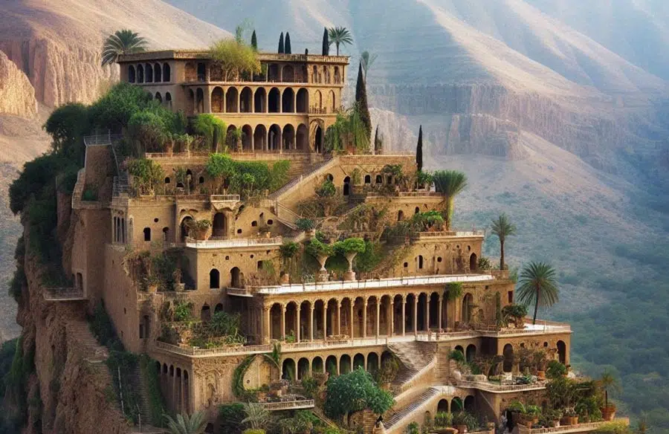

**PRESENT DAY**

The industrialization age helped in the transition from pre-modern farming to modular farming. The industrial age was the age when the world was going through a developmental transformation and the time modular farming met with modern advancement. Its outline shows a fascinating intertwining of innovative technologies and the rapid increase in demand of urban landscapes. It is marked by unprecedented shifts in societal structures, technological advancements, and an alteration in the framework of agricultural practices. The surge of urbanization during the Industrial Age substantially impacted the development of vertical farming.

As cities bloomed with industrial advancements, their magnetized populations, lured by employment prospects and modern amenities, migrated in significant numbers. With swelling urban populations and escalating demands for space, traditional agricultural practices were precariously positioned. The rampant urbanization pressured agrarian lands and distanced consumers from production sites. This posed logistical and freshness challenges. Subtly, these changes guided the trajectory of agriculture toward an exploration of upward, proximate farming possibilities.

The ever-increasing number of cities demanded innovative food production solutions to surmount spatial limitations. Thus, the seeds were sown for vertical endeavors within the agricultural domain, rooting vertical farming history in the soil of urban challenges. All leading to the introduction of Hydroponics, aeroponic and aquaponic vertical farming.

**FUTURE PLAN**

The evolution of vertical farming is a tale of innovation, persistence, and a steadfast drive toward sustainability and efficiency.

From cutting-edge technological enhancements and scalable models to improved crop varieties and resource-efficient systems, our contemporary era is lush with advancements that echo future promises.

An electrifying chapter in vertical farming history is being written as we speak, integrating Artificial Intelligence (AI) and robotics, revolutionizing how crops are grown, monitored, and harvested. AI algorithms optimize growth recipes, light adjustments, nutrient and water dispersal based on real-time plant behavior, and many other environmental conditions.

Robotics, with their meticulous, untiring precision, ensure individualized plant care, thereby maximizing yield and minimizing waste. This symbiosis of biology and technology unfolds a fascinating future chapter of vertical farming history. According to Nona Yehia, "We believe that food should not only nourish our bodies but also nurture our communities and create opportunities for all" (Mainwaring, 2023).A city with many tall buildings

1. **TYPES OF MODULAR FARMING.**
2. **Aeroponic:**

Aeroponic systems grow plants in an air or mist environment without the use of soil or hydroponic medium. Plant roots are suspended in a nutrient-rich mist, allowing for optimal oxygenation and nutrient absorption. Aeroponics promotes rapid growth, water conservation, and reduced disease risk compared to traditional soil-based farming.

1. **Hydroponics:**

Hydroponic systems grow plants without soil by delivering nutrient-rich water directly to the plant roots. This technology allows for precise control over nutrient levels, pH, and water usage, resulting in efficient nutrient uptake and accelerated plant growth. Hydroponics is commonly used to maximize space and resource efficiency.

2a). Important aspects of Hydroponic

**i). Nutrient content:**

In hydroponics, the nutrient uptake process is critical as it significantly impacts plant growth and yield. Unlike soil-based cultivation, hydroponic systems deliver nutrients directly to plant roots through a nutrient-rich water solution.

**Macro-nutrient:**

Macronutrients are essential nutrients required by organisms in relatively large quantities to support various physiological functions, growth, and development.

Types of Macro-nutrient

**Primary Macro-nutrient:**

The primary macronutrients include Nitrogen (N), Phosphorus (P), and Potassium (K), often referred to as N-P-K.

**Secondary Macro-nutrient:**

Secondary macronutrients are Calcium (Ca), Magnesium (Mg), and Sulfur (S).

**Micro-nutrient:**

Micronutrients are essential nutrients required by organisms in relatively small quantities for optimal health and functioning. Micronutrients required include Iron (Fe), Manganese (Mn), Boron (B), Molybdenum (Mo), Zinc (Zn), Copper (Cu), and Chlorine (Cl).

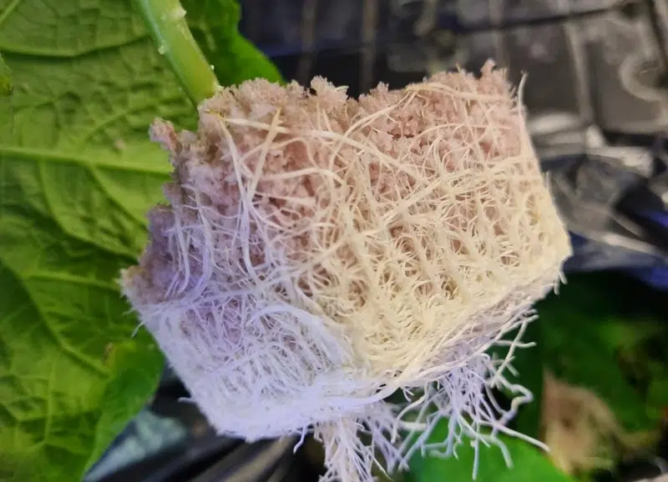

**Crafting the perfect nutrient mix**

* **Nutrient solution preparation:** Start by choosing a high-quality hydroponic nutrient mix that covers all essential macro and micronutrients. Follow the manufacturer’s instructions for initial mixing.
* **Customization:** As you gain experience, you can customize nutrient ratios to better suit your plants’ needs. You can use individual nutrient salts for this purpose, but make sure that you understand the compatibility and interactions between different nutrients.
* **Water quality:** The quality of water used in preparing the nutrient solution is crucial. Use clean, pure water to prevent unwanted elements from entering your system.
* **Testing and adjusting:** Regularly test the nutrient solution for pH and Electro-Conductivity (EC) to ensure nutrient availability and correct any imbalances. Adjust the nutrient concentration and pH as needed to maintain optimal levels.
* **System flushing:** Periodic flushing of the system with clean water helps to prevent salt buildup and nutrient lockout, ensuring a consistent nutrient supply to your plants.
* **Continuous learning:** Engage in communities, read relevant literature, and experiment cautiously to improve your understanding and ability to craft the perfect nutrient mix for your hydroponic farm**.**

**ii). pH and electro-conductivity**

**iii). Water (source and delivery system) and (quality, filtration and treatment methods).**

1. **Water source and delivery system:**

Efficient water delivery systems maintain a consistent flow of nutrient-rich water, catering to the needs of your hydroponic plants. There are two types of water delivery system namely:

1. Gravity-fed
2. Pump-driven system.

|  |  |
| --- | --- |
| **DIFFERENCE BETWEEN Gravity-fed system and pump-driven system** | |
| **Gravity-fed system** | **Pump-driven system** |
| * Its process is simple and has a low maintenance. | Its process offers better control and efficiency in water delivery. |

1. **Water quality, filtration and treatment method:**

Water filtration and treatment remove undesirable elements, ensuring the water quality is good and safe. The water quality directly affects the health and productivity of the hydroponic plant growth.

**Types of Filtrations**

i). Mechanical filtrations.

ii). Biological Filtrations.

iii). Chemical Filtrations.

iv). Disinfection.

|  |  |  |  |
| --- | --- | --- | --- |
| **Mechanical filtrations** | **Biological Filtrations** | **Chemical Filtrations** | **Disinfection** |
| Mechanical filtration is the first line of defense, which removes solid particles and debris from the water. It operates on a physical level, using filters or sieves to trap and remove particulate matter. It is crucial for preventing clogs in the system and maintaining clear water pathways. | Biological filtration tackles the invisible, microscopic realm. It employs beneficial bacteria to break down harmful substances like ammonia and nitrites, common in recirculating systems into less harmful substances. | Chemical filtration delves into the molecular level, using activated carbon or other adsorbent materials to remove unwanted chemicals and odors from the water. It’s instrumental in ensuring that the nutrient solution remains pure and free from potentially harmful substances. | Disinfection through UV, ozone, or chlorination eliminates pathogens, ensuring a healthy environment and preventing disease outbreaks for the hydroponic plants. |

**iv). Temperature and oxygenation.**

**v). Pest and disease management:**

Implementing IPM(Integrated Pest Management) strategies in a hydroponics setup involves monitoring for pest and disease presence, identifying potential risks, and applying control measures judiciously. This comprehensive approach aims to manage pest and disease issues sustainably and effectively, ensuring the hydroponic garden’s long-term success.

1. **Aquaponics:**

Aquaponic modular farming is a sustainable farming method that integrates aquaculture (the farming of aquatic animals) and hydroponics (the cultivation of plants in water) in a closed-loop system. In aquaponic modular farming, fish and plants are cultivated together in a symbiotic environment where each component benefits from the other.

1. **TECHNOLOGIES THAT MODULAR FARMING UTILITIZES AND THEIR USES.**

**i). LED Lighting:**

Light-emitting diode (LED) lighting systems are used in modular farming to provide the specific spectrum and intensity of light required for plant growth. LEDs are energy-efficient, produce little heat, and can be customized to match the light needs of different plant species and growth stages. LED lighting allows for year-round crop production in indoor environments and can be adjusted to optimize photosynthesis and plant morphology.

LED lighting


**ii). Climate Control Systems:**

Climate control systems regulate temperature, humidity, and airflow within modular farming facilities to create optimal growing conditions for crops. Heating, ventilation, and air conditioning (HVAC) systems maintain stable environmental parameters, preventing temperature extremes and humidity fluctuations that can stress plants and inhibit growth. Climate control systems are essential for year-round production and crop consistency in indoor farming environments.

**iii). Sensors and Automation:**

Sensors are used to monitor environmental variables such as temperature, humidity, light levels, and nutrient concentrations in real time. Automated systems integrate sensor data to control climate, irrigation, and nutrient delivery, optimizing resource usage and minimizing human intervention. Automation increases operational efficiency, reduces labor costs, and ensures precise management of growing conditions in modular farming systems.

**iv). Vertical Farming Structures:**

Vertical farming structures such as racks, shelves, and towers are designed to maximize growing space in limited footprints. These structures support vertical stacking of growing modules, allowing for efficient use of space and high crop density. Vertical farming structures may incorporate conveyor systems, robotic arms, or movable platforms for easy access to plants and maintenance tasks.

**v). Water Recycling Systems:**

Water recycling systems capture and treat excess irrigation water and condensation within modular farming facilities. Recirculating water reduces water consumption, minimizes nutrient runoff, and conserves resources. Water recycling systems may include filters, pumps, and reservoirs to maintain water quality and nutrient balance in hydroponic and aeroponic systems.

**E. Benefits of modular farming:**

1. **Space Efficiency**:

Vertical farming allows for the cultivation of crops in a smaller footprint compared to traditional farming methods. This is particularly useful in urban areas where land availability is limited.

1. **Year-Round Production:**

By controlling environmental factors such as temperature, humidity, and light, modular farming enables year-round crop production regardless of external weather conditions. This consistency can help meet consumer demand and stabilize food supply chains.

1. **Water Conservation:**

Hydroponic and aeroponic systems used in modular farming typically require less water compared to traditional soil-based agriculture. Water usage is minimized through techniques such as recirculating water systems and precise irrigation methods.

1. **Reduced Pesticide Use:**

Indoor farming environments can be closely monitored, reducing the need for chemical pesticides. Integrated pest management techniques can be employed to control pests and diseases more sustainably.

1. **Energy Efficiency:**

While indoor farming may require energy inputs for lighting and climate control, advances in LED lighting technology and energy-efficient climate control systems have made modular farming more sustainable. Additionally, renewable energy sources can be integrated to further reduce environmental impact.

1. **Local Food Production:**

Modular farms can be established close to urban centers, reducing the distance food needs to travel from farm to table. This can result in fresher produce, lower transportation emissions, and support for local economies.

1. **Crop Diversity:**

Vertical farming enables the cultivation of a wide variety of crops, including leafy greens, herbs, fruits, and vegetables. This diversity allows farmers to respond to changing market demands and consumer preferences.

1. **Adaptability:**

Modular farming systems can be easily scaled up or down to meet demand or accommodate changes in available space. This flexibility makes them suitable for a range of settings, from small-scale urban operations to larger commercial ventures.

1. **Alternative to Modular Farming.**

An alternative to modular farming is traditional outdoor farming methods. Traditional outdoor farming represents a time-tested approach to agriculture that utilizes natural resources and traditional farming knowledge to produce food, fiber, and other agricultural products for human consumption and livelihoods.

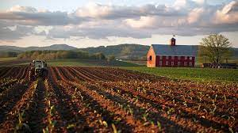

1. **Disadvantage of Modular Farming.**

Here are some reasons why traditional outdoor farming could be considered an alternative to modular farming:

1. **Lower Initial Investment:**

Setting up a modular farm, especially on a commercial scale, often requires significant capital investment in infrastructure, technology, and specialized equipment. In contrast, traditional outdoor farming may have lower initial setup costs, particularly for farmers who already own or have access to land and basic farming equipment.

1. **Land Availability:**

In rural areas where land is abundant and relatively inexpensive, traditional outdoor farming may be more practical and cost-effective than investing in indoor modular farming facilities. Farmers may prefer to utilize existing land for crop production rather than investing in vertical or indoor farming infrastructure.

1. **Crop Variety and Scale:**

While modular farming is well-suited for growing certain types of crops such as leafy greens, herbs, and microgreens, traditional outdoor farming can accommodate a broader range of crops, including staple grains, fruits, and field vegetables. Additionally, outdoor farming allows for larger-scale production, making it more suitable for certain crops that require extensive acreage.

1. **Natural Resource Availability:**

In regions with ample sunlight and water resources, traditional outdoor farming may require fewer inputs in terms of artificial lighting and irrigation compared to indoor modular farming. This can result in lower operating costs and potentially higher yields for certain crops grown outdoors under optimal natural conditions.

1. **Traditional Knowledge and Practices:**

Many farmers have generations of experience and knowledge in traditional outdoor farming techniques specific to their local climates and environments. While modular farming relies on advanced technologies and controlled environments, traditional farmers may prefer to leverage their expertise in soil management, crop rotation, and pest control to achieve successful crop yields.

1. **Market Demand and Consumer Preferences:**

Some consumers may prefer produce grown using traditional outdoor farming methods, associating it with notions of "natural" or "organic" farming practices. Additionally, certain agricultural certifications and labels may be more readily available or recognized for traditionally farmed products, catering to specific market segments.

1. **TABULAR DIFFERENCE OF MODULAR FARMING AND TRADITIONAL OUTDOOR FARMING.**

|  |  |  |
| --- | --- | --- |
| Points | Modular Farming (indoor) | Traditional Outdoor Farming |
| Environmental Factor | It involves growing crops indoors or in controlled environments. Environmental factors like temperature, humidity, and light are closely monitored and controlled to optimize plant growth. | It relies on open fields or outdoor environments for crop cultivation. Crops are exposed to natural environmental conditions, including sunlight, rainfall, and temperature variations. |
| Land Use | It can be implemented in a smaller footprint compared to traditional outdoor farming. | It requires larger land areas for crop cultivation, with fields often spanning vast expanses of rural landscapes. Land availability and soil quality are significant factors in determining the feasibility and productivity of outdoor farming operations. |
| Resource Efficiency | The closed-loop systems in modular farming minimize water usage, reduce nutrient runoff, and optimize energy consumption through technologies like LED lighting and climate control. | It relies on natural resources like soil, water, and sunlight for crop growth. While outdoor farming systems are inherently energy-efficient in terms of sunlight usage, they may be less efficient in water usage and nutrient management, leading to potential environmental impacts such as soil erosion and nutrient runoff. |
| Crop Diversity and Seasonality | It enables year-round production of a wide variety of crops, including leafy greens, herbs, and vegetables, regardless of seasonal variations. Controlled indoor environments allow for continuous cultivation and rapid crop growth. | It involves seasonal production cycles, with specific crops planted and harvested according to local climate conditions and growing seasons. Crop diversity may be limited by climate and soil conditions, with certain crops only suitable for specific regions or seasons. |
| Pest and Disease Management | It can provide a more controlled environment for pest and disease management compared to traditional outdoor farming. Integrated pest management (IPM) techniques, biological controls, and physical barriers can help minimize pest and disease pressures in indoor farming systems. | The reliance on chemical pesticides and herbicides being common practices. Outdoor crops are more susceptible to pest infestations and disease outbreaks due to exposure to natural environmental conditions. |

1. **Effects of Modular Farming (Positive and negative).**

Modular farming, also known as indoor or vertical farming, can have both positive and negative effects on the environment. Here are some of the key considerations:

**Positive Effects:**

1. **Resource Efficiency:**

Modular farming can be more resource-efficient compared to traditional outdoor farming methods. It typically requires less land, water, and fertilizers to produce the same number of crops due to controlled environments and optimized growing conditions.

1. **Reduced Land Use:**

By growing crops vertically or indoors, modular farming can help conserve agricultural land, which is particularly valuable in urban areas where land availability is limited. This can help prevent deforestation and habitat destruction associated with expanding agricultural areas.

1. **Water Conservation:**

Hydroponic and aeroponic systems used in modular farming often consume less water compared to traditional soil-based farming, as water is recirculated within the system rather than lost to evaporation or runoff. This can help alleviate pressure on freshwater resources, especially in regions facing water scarcity.

1. **Reduced Pesticide Use:**

Controlled indoor environments in modular farms can help reduce the need for chemical pesticides and herbicides, as pests and diseases can be managed more effectively through integrated pest management techniques. This can minimize chemical runoff and its adverse effects on soil and water quality.

**5. Local Production:**

Modular farming allows for year-round production of fresh produce closer to urban centers, reducing the need for long-distance transportation and associated greenhouse gas emissions. This can contribute to lower carbon footprints for food production and distribution.

**Negative Effects**

1. **Energy Consumption:**

Modular farming facilities require energy for lighting, heating, ventilation, and other operational needs. Depending on the energy source, this can result in increased greenhouse gas emissions and contribute to climate change. However, advancements in energy-efficient technologies and renewable energy integration can mitigate these impacts.

1. **Waste Generation:**

The production of modular farming systems, including construction materials, equipment, and packaging, can generate waste and environmental pollution. Additionally, crop residues and unused nutrients in hydroponic systems may require proper management to prevent nutrient runoff and water contamination.

1. **Light Pollution:**

Artificial lighting used in indoor farming facilities can contribute to light pollution, which can disrupt ecosystems and have negative effects on wildlife behavior, particularly nocturnal species. Light pollution mitigation measures such as shielding lights and using timers can help minimize these impacts.

1. **Dependency on Technology:**

Modular farming relies heavily on technology, including sensors, automation systems, and climate control equipment. Dependency on these technologies can pose risks in terms of system failures, cybersecurity threats, and electronic waste generation if not properly managed.

1. **Loss of Biodiversity:**

Intensive monoculture production in modular farming systems may lead to reduced biodiversity compared to traditional outdoor farming methods. Limited crop diversity and genetic uniformity can increase vulnerability to pests, diseases, and crop failures over time.

**2 ISSUE-DRIVEN QUESTIONS AND THEIR SOLUTION**

**ISSUE 1**:

How can modular farming address food insecurity in urban areas?

Solution:

Implementing community-based modular farming initiatives in urban neighborhoods with limited access to fresh produce.

Providing training and support to residents to establish and maintain modular farming systems, empowering communities to produce their own food.

Partnering with local governments, non-profit organizations, and businesses to secure funding and resources for modular farming projects in underserved communities.

Establishing farmers' markets and distribution networks to facilitate the sale and distribution of locally grown produce from modular farms to residents.

Educating community members about the benefits of modular farming, nutrition, and sustainable food practices to promote long-term food security and resilience.

**Issue 2:**

How can modular farming contribute to environmental sustainability and mitigate the impacts of climate change?

Solution:

Utilizing renewable energy sources, such as solar panels and wind turbines, to power modular farming facilities and reduce reliance on fossil fuels.

Implementing water recycling and conservation techniques, such as closed-loop irrigation systems and rainwater harvesting, to minimize water usage and reduce environmental impact.

Incorporating sustainable farming practices, such as crop rotation, integrated pest management, and organic fertilizers, to enhance soil health and biodiversity in modular farming systems.

Partnering with environmental organizations and research institutions to develop and promote best practices for sustainable modular farming and share knowledge and resources.

Advocating for policies and incentives that support the adoption of modular farming and sustainable agriculture practices at local, national, and international levels to address climate change and promote environmental stewardship.

**Reference:**

1. Vertical Farming Planet. (n.d.). The Full History of Vertical Farming: When Did It All Start? Retrieved from <https://verticalfarmingplanet.com/the-full-history-of-vertical-farming-when-did-it-all-start/>. Retrieved 20 March 2024.
2. Vertical. (n.d.). Articles. Retrieved from <https://vertical.mt/articles/> . Retrieved 20 March 2024.
3. Mainwaring, Simon. "Vertical Harvest: Cultivating Food Futures & Social Impact." Forbes, 31 July 2023, <https://www.forbes.com/sites/simonmainwaring/2023/07/31/vertical-harvest-cultivating-food-futures--social-impact/?sh=160541b87ac3>.